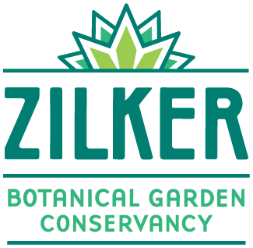
Visitor Services Associate
Zilker Botanical Garden Conservancy
Part-time, hourly

The Zilker Botanical Garden Conservancy works in partnership with the city of Austin to provide a zen escape from the busy city life. The Conservancy is a small nonprofit who aims to enhance the Garden.
The Zilker Botanical Garden Conservancy is seeking a visitor services associate to add to our team who will be responsible for collection of admissions, sale of memberships, and gift shop sales at ZBG while providing excellent customer service. Individuals may primarily focus on one area (admissions booth or gift shop), however, all are expected to be cross-trained.

Essential Duties and Functions
Essential duties and functions, pursuant to the Americans with Disabilities Act, may include the following:
- Welcome guests to Zilker Botanical Garden
- Process Garden admissions
- Gift shop sales
- Promote and sell Garden memberships
- Answer questions from the public
- Demonstrate regular and punctual attendance
- Responsible for opening the booth and gate at the start of the day/ or closing it at the end of the day
- Cash handling
- Accurately enter admissions/sales data
- Accurately closeout and report daily totals
- Must be available 15 to 25 hours a week
- Wear a uniform when clocked in
- Work outdoors rain or shine

Qualifications
- High School diploma or GED
- Two years of experience with cash register or point of sale (POS) equipment
- Reliable transportation and a valid driver’s license or ID
- Customer service experience in a position that requires a high degree of accuracy and sensitivity
- Confident and outgoing customer service attitude
- Ability to work weekends and evenings as required. Additional hours may be required during peak periods and events
- Ability to work with a computer (PC and IPAD)
- Excellent interpersonal skills

Preferred Qualifications
- Experience processing credit card payments
- Museum or public garden experience
- General knowledge of gardening and plants with training
- Demonstrated ability to communicate effectively and interact cooperatively with visitors and coworkers
- Experience interacting with the public and handling questions in a professional manner
- Demonstrated flexibility concerning shifting priorities
- Works well with interruptions and ability to multitask
- Experience with detail-oriented procedures
- Bilingual (English/Spanish) is a plus
This position is temporary/seasonal and part-time. A criminal history background check is required for all candidates under consideration. Zilker Botanical Garden Conservancy is an Equal Opportunity Employer. All qualified applicants will receive considerations for employment without regard to race, color, religion, gender, national origin, age, disability, or veteran status.
How to apply:
Email resume to operations@zbgconservancy.org with Visitor Services Associate in the subject line.

