**Club Event Publicity Request Form**

**Events Page on Zilker Botanical Garden Website, “Garden Happenings,” AAGC Facebook**

**Instructions:** Email the completed form and any related attachments to [publicity.aagc@gmail.com](mailto:publicity.aagc@gmail.com) with the Subject Line “Club Event Publicity Form” at least two (2) weeks before the event.

Club Name ________________________________ Today’s Date ______________________________

Contact Name _____________________________ Email _________________ Phone ­­­­______________

**Publicity Options Requested.** *(Put an “X” next to all that apply. Inclusion is based on space, web rules.)*

__ On Events page [Zilker Botanical Garden Website](https://zilkergarden.org/events/)

Questions? Ask Donna Friedenreich [publicity.aagc@gmail.com](mailto:publicity.aagc@gmail.com)

__ In **Garden Happenings**, sent to AAGC members, ZBG website link

Questions? Ask Sally Dickson [skdickson@yahoo.com](mailto:skdickson@yahoo.com)

__ On AAGC’s **Facebook page** Questions? Ask Marion Alsup [marionalsup@aol.com](mailto:marionalsup@aol.com)

**Event Information – Club Meetings, Special Events, Activities**

**Location of Event**

*At Zilker Botanical Garden* (Check all that apply) Other _________________________________

_____ Auditorium _____ Greene Room _____Oak Grove _____ South Lawn

*Outside of Zilker Botanical Garden*

Location Name ­­___________________________________________________________________

Address __­­­_______________________________________________________________________

*Virtual Event?*  ____ Yes ____ No

How to register or obtain Zoom link information: _______________________________________

Email____________________________________ Phone Number__________________________

**Event Name or Title:** _________________________________________________________________

Day 1______________ Date _________Start Time _____________End Time __________________

Day 2______________ Date _________ Start Time _____________End Time __________________

**Speaker/Demonstrator/Leader**  _____ Yes _____ No If Yes, please provide:

Name/Subject of Session ____________________________________________________________

Speaker’s Name ___________________________________________________________________

Speaker’s Organization______________________________________________________________

In **100 words or less**, describe the event, including names and affiliations of any speakers, their topic and/or any activities at the event. What will make people want to attend?

(See examples on [www.zilkergarden.org](http://www.zilkergarden.org) – Events link)

**Additional Details about the Event**

Extra costs, beyond the Garden Admission Fee (Music events, sales, fundraisers, etc.)

Yes ___ No ____ If Yes, how much? ___________________

Event____ is *open to the public and other AAGC club members* ***or***

____ is *private and/or* *limited to this club’s members*

Major Co-Sponsors ____________________________________________________________________

_____________________________________________________________________________________

How a potential attendee can obtain additional information ____________________________________

_______________________________________________________________________________________

**(Link to event details on club website AND/OR Club Contact and email)**

**Attachments**

Provide all files you want us to consider using, such as club logo, photos or images supporting the event, or a flyer.

***Flyers for events held at Zilker Botanical Garden must include the ZBG Information below, and the four logos***



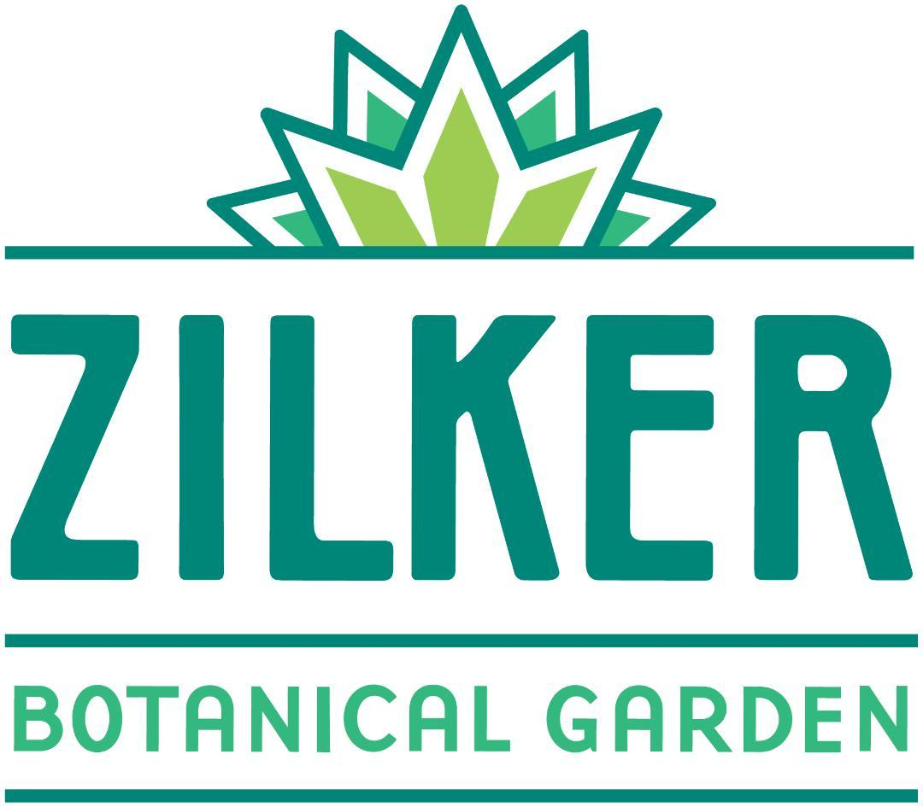

**CHECKLIST**

* **Confirm all Event Information is provided - Location, Title, Speaker, Date and Time**
* **Complete the 100 words or less box with text that will be used in promotion on the website Events link, in Garden Happenings, and on Facebook.**
* **Provide additional detail about the Event that will be included in the promotion content (Fees, Open to Public, Co-Sponsors, Additional Information Contact).**
* **If desired, attach flyer, club logo, photos, images and submit with Publicity Form.**
* **Email the completed form and attachments at least 2 weeks prior to the Event.**

***All good to go?***

**Email to** [publicity.aagc@gmail.com](mailto:publicity.aagc@gmail.com)

**Subject Line: Club Event Publicity Request - Club Name**

**Subject Line: Club Event Publicity Request - Club Name**