**Club Event Publicity Request Form**

***Events Page on Zilker Botanical Garden Website, “Garden Happenings,” AAGC Facebook***

**Instructions:** Email the completed form and any related attachments to [publicity.aagc@gmail.com](mailto:publicity.aagc@gmail.com) with the Subject Line “Club Event Publicity Form” at least two (2) weeks before the event to ensure that there is time to post on the ZBG website. Requests for Garden Happenings may be submitted as early as two months before the event and may be published in two editions of Garden Happenings before your event.

Club Name ____________________________________________________ Today’s Date _________

Contact Name __________________ Email __________________________ Phone ­­­­___________________

**Publicity Options Requested.** *(Put an “X” next to all that apply. Inclusion is based on space, web rules.)*

__ On Events page [Zilker Botanical Garden Website](https://zilkergarden.org/events/)

Questions? Ask Donna Friedenreich [publicity.aagc@gmail.com](mailto:publicity.aagc@gmail.com)

__ In **Garden Happenings**, sent to AAGC members, ZBG website link

Questions? Ask Sally Dickson [skdickson@yahoo.com](mailto:skdickson@yahoo.com)

__ On AAGC’s **Facebook page** Questions? Ask Marion Alsup [marionalsup@aol.com](mailto:marionalsup@aol.com)

**INFORMATION ABOUT THE CLUB MEETING, SHOW, SALE OR SPECIAL EVENT**

**Location**

*At Zilker Botanical Garden* (Check all that apply)

____ Auditorium ____ Greene Room ____Oak Grove ____ South Lawn ____ Herb and Rose Garden

*Outside of Zilker Botanical Garden*

Location Name ­­___________________________________________________________________

Address __­­­_______________________________________________________________________

*Virtual Component?*  ____ Yes ____ No

How to register or obtain Zoom link information:

Email________________________________________ Phone Number__________________________

**Event Name:** ____________________________________________________________________________

Day 1: Day of the Week___________ Date ___________ Starts _________ Ends ___________

Day 2: Day of the Week ______ ____ Date____________ Starts _________ Ends ___________

**Program Title:** ___________________________________________________________________________

**Speaker’s Name:** _________________________________________________________________________

**Speaker’s Organization**: ___________________________________________________________________

**Event Description**. In **100 words or less**, describe the event, the topic, and any activities, such as plant sale, show, auction, etc., and include names and affiliations of speakers. What will make people want to attend?

(See examples on [www.zilkergarden.org](http://www.zilkergarden.org) – Events link)

**Speaker Bio**. In **100 words or less**, tell us about the speaker and the expertise they bring to this program.

(See examples on [www.zilkergarden.org](http://www.zilkergarden.org) – Events link)

In **100 words or less**, describe the event, including names and affiliations of any speakers, their topic

**Additional Details about the Event**

***Does this activity take place during your regular club meeting day/time? ____ Yes ____ No***

If Yes, please use this language in your club publicity to be consistent with the ZBG Events Calendar:

"Open to the public, free to attend."

***Is this show, sale or seminar, held on a different day/time than your club meeting? ____ Yes ____ No***

If Yes, please use this language in your club publicity to be consistent with the ZBG Events Calendar:

“Included with admission, free for Conservancy members.”

***Are there any charges for this activity, such as a workshop registration, materials fee, or lunch fee?***

***____ Yes ____ No***

If Yes, please provide a brief description in the box to be included in your publicity.

*Example: There is a $20 fee for materials for the workshop, and you take a flower arrangement home."*

*OR "There is a $15 luncheon fee."*

**NOTE:** Any club fundraising activities are subject to the 15% Net Profit fee. If this event is subject to the Net Profit Fee, the AAGC Treasurer will get you the appropriate form and instructions.

Major Co-Sponsors ____________________________________________________________________

_____________________________________________________________________________________

How can a potential attendee obtain more information? (Please link to Event Details on the Club’s Website AND/OR email of Club Contact ____________________________________________________________

______________________________________________________________________ ____________

**Attachments**

List name of files you want us to consider using, such as club logo, photos or images supporting the event, or a flyer.

***Flyers for events held at Zilker Botanical Garden must include the ZBG Information below, and the four logos***



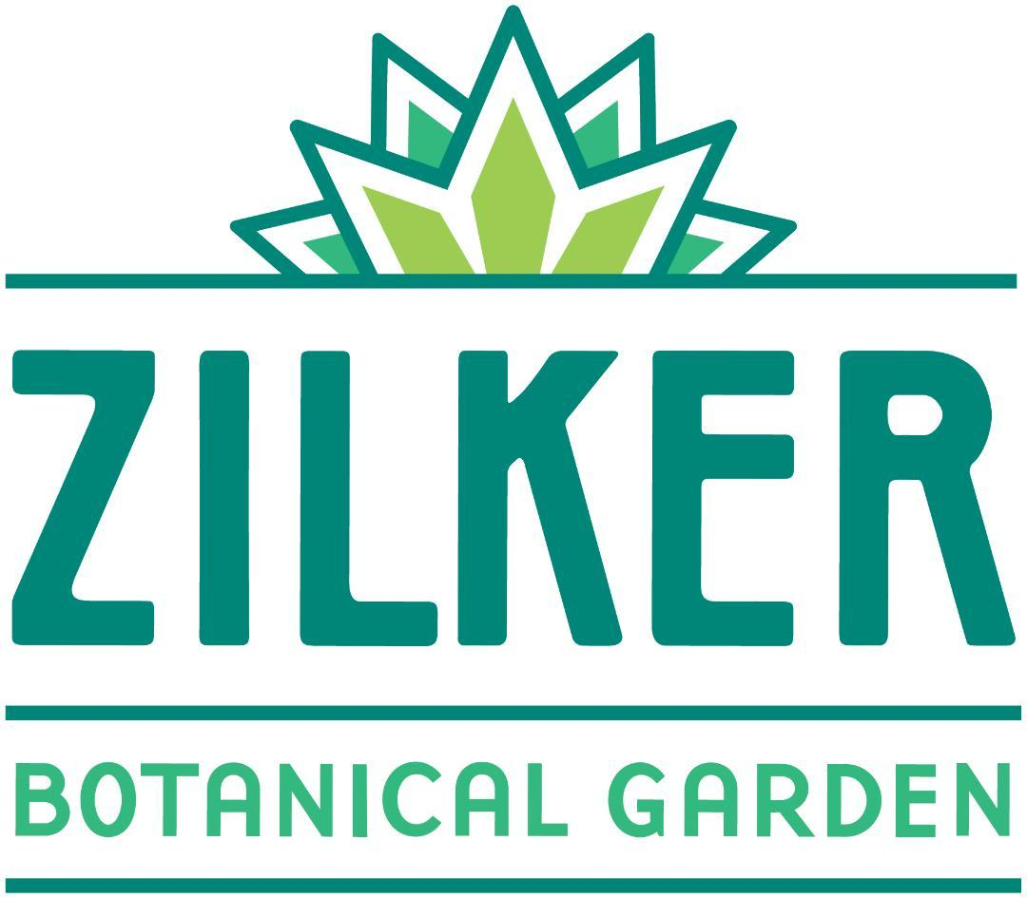

**CHECKLIST**

* **All Event Information is provided - Location, Title, Speaker, Date and Time**
* **Boxes for Event and Speaker details are complete. This text will be used in publicity on ZBG’s Events link, in AAGC Garden Happenings, and on AAGC Facebook.**
* **Additional detail is included such as Fees, Co-Sponsors, Club Contact for more info.**
* **If desired, a flyer, club logo, photos, or images are submitted with Publicity Form.**
* **Email the completed form and attachments at least 2 weeks prior to the Event.**

***Remember, Garden Happenings requests can be submitted as much as two months in advance, and we hold information for use on website as well.***

***All good to go?***

**Email to** [publicity.aagc@gmail.com](mailto:publicity.aagc@gmail.com)

**Subject Line: Club Event Publicity Request - Club Name**

**Subject Line: Club Event Publicity Request - Club Name**