Guidelines, Terms, and Conditions for the 2023 Woodland Faerie Trail

1. Faerie homes should reflect the romantic, magical, surprising, and natural spirit of the folk who will live in them!

2. Faerie homes should be built to withstand wind, rain, and Texas summer heat. The 2023 Woodland Faerie Trail installation will begin on select dates from May 15th – May 21st with cleanup occurring on select dates from July 8th - July 22nd.

3. All faerie architects and contractors should be respectful of the existing living species in the garden. Please do not injure or uproot living plants, such as ferns, mosses, and flowers. We want the faeries to invite us all back next year!

4. Mounting your home to a base of up to 4' square is a good thing to include if you have features outside the dwelling (such as swings, gardens, benches, etc.). Bases can be made of plywood or tree cookies (a cross-section of a tree stump). Please be sure that if you choose to mount your home to a base, the entire base is hidden or will blend in with the natural elements.

5. Do not use any living plants in your faerie home and surroundings. Unfortunately, faeries are notoriously bad at housekeeping and tend not to water their own house plants enough to keep them beautiful all summer long.

6. Approved Materials for Use in Building:
• Sticks
• Pebbles/rocks
• Dead leaves
• Bark
• Dry grasses
• Feathers
• Pinecones
• Nuts
• Clay
• Shells
• Anything naturally occurring from around your home, office or school
Examples of what to do:
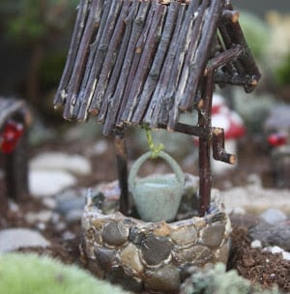
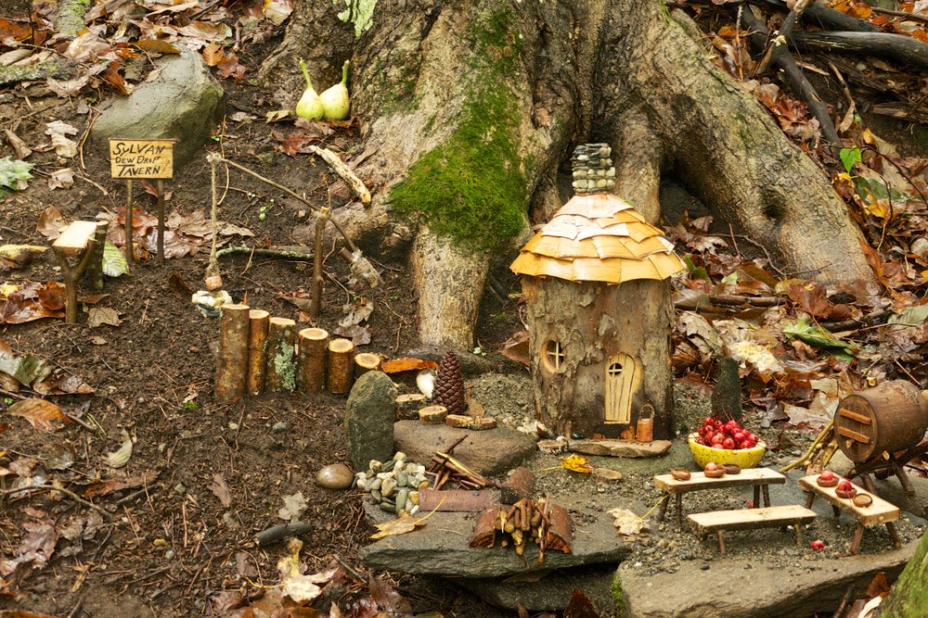

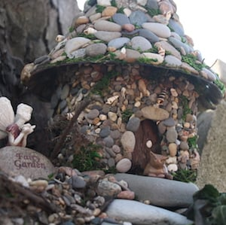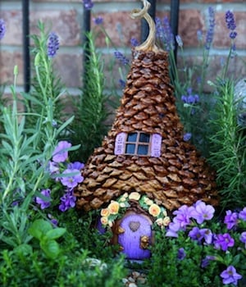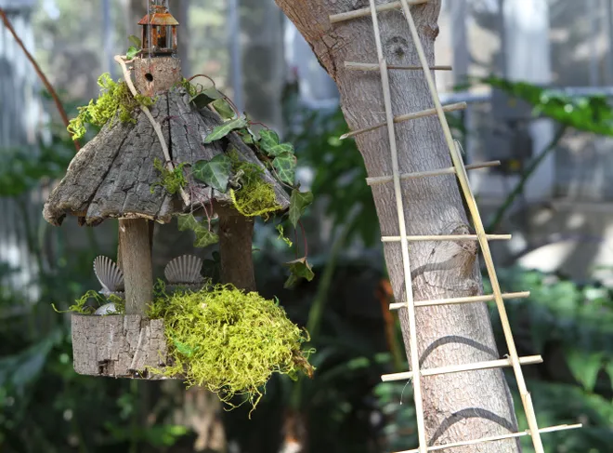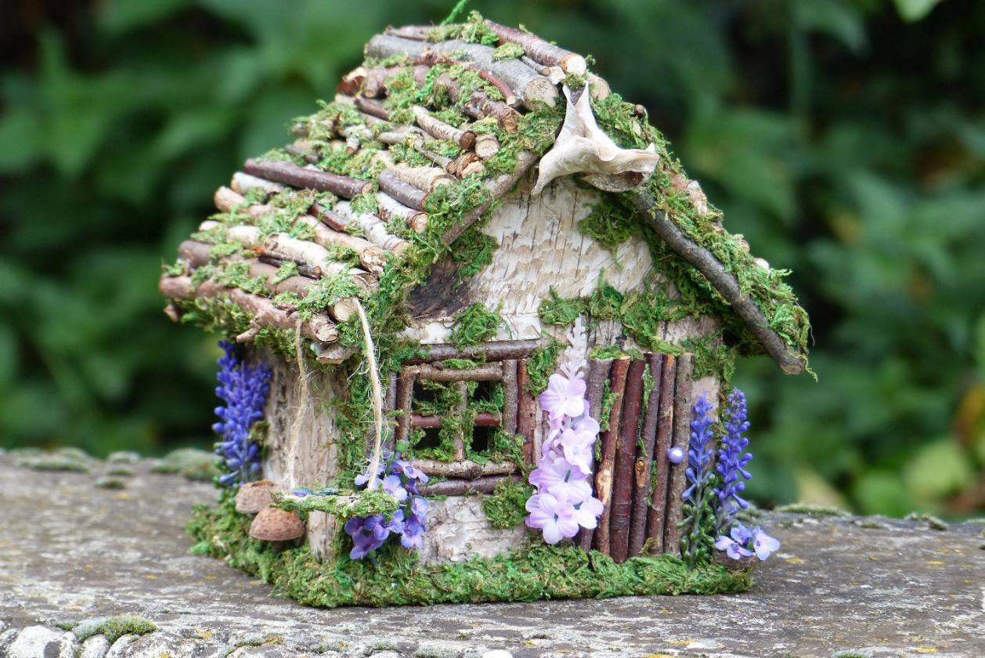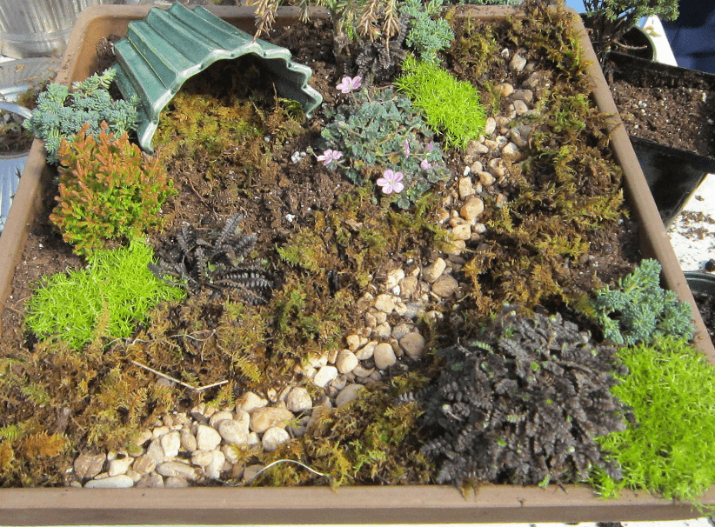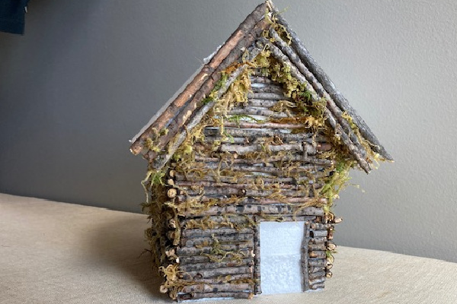

7. Please DO NOT use these and other artificial materials: (use of these materials will cause the faeries to remove all or part of your faerie house from the garden)
• Craft foam
• Plastic
• Nylon and polyester fabric
• Styrofoam
• Mirrors, glass beads, or glass or any kind
• Faerie lights or other electric lighting (lights powered by solar energy are allowed)
We encourage you to avoid using prefabricated materials whenever possible! We want to see your creativity and unique designs from local materials.
Examples of what not to do:
No sharp edges, glass beads, or live plants
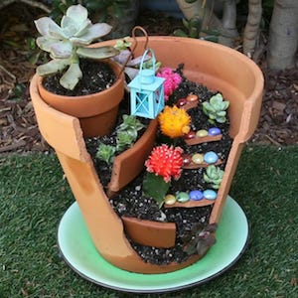

No glass beads
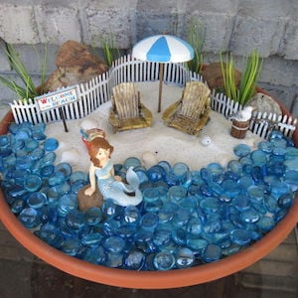
No live plants, we discourage heavy use of prefabricated store bought/plastic materials
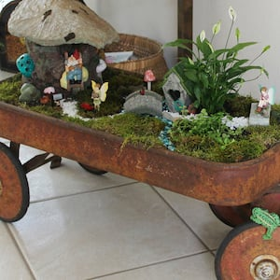
8. Faerie homes may be any size you wish as long as you do not exceed the size of your plot. (Up to 4'x4')

9. Faerie architects and contractors can install their homes during select times. This is new this year to allow for more interaction between garden staff and faerie architects. The dates for installation are:
May 15th, 18th, 20th, 21st
To register for a Faerie Trail plot this year you will need to sign up in GivePulse for an installation shift on one of our offered dates. Please note, plot registrations are not confirmed until you have registered in GivePulse for an installation shift. If you do not have a GivePulse account, simply set one up here: https://learn.givepulse.com/ . Once your account is set up, login and use this link: https://givepul.se/fhi3c2 to register for an installation date. To register you will need this magical case sensitive registration code that the faeries provided us: Toothpaste
It's what the tooth fairy uses to fix her wand!
Please ensure you can commit to cleaning up your fairy house when considering registering for a plot.

10. You may choose to visit your plot earlier than that to better incorporate your home into your
specific environment.

11. We rely on faerie architects to retrieve their homes at the closing of the exhibit. Please plan on reclaiming your home for next year's faeries. You may also use it to create a permanent insect hotel in your personal garden (vital for attracting pollinators like butterflies, bees, and other helpful critters) after the Exhibit closes.

Cleanup Dates are: July 8th, 19th, 21st, and 22nd. We will have a special cleanup party on July 22nd to thank you for all your work! Wings are encouraged, it’s faster to fly around while you clean!

12. The Woodland Faerie Trail is a place of magic, free from political overtones. Please help us keep the Trail magical and do not include political or offensive messaging or themes or the faeries will have to remove your creation.

13. We reserve the right to decline or remove any Faerie home that does not meet the standards described above so please consider your materials and design and ensure you can make it to one of our cleanup days before registering.

If you have any questions about how to create, install, maintain, or reclaim your Faerie home, please e-mail lindsay.loftin@austintexas.gov, or call 512-477-8672

"The world is full of magic things, patiently waiting for our senses to grow sharper."
-W.B. Yeats
The 2023 Faerie Trail has been brought to you in partnership with the City of Austin, the Austin Parks & Recreation Department, and the Zilker Botanical Garden Conservancy.

