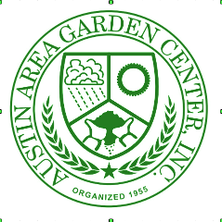
FY 2024 AAGC Club Educational Programs and Activities
October 2023 – September 2024

Club Name: ___________________ Date Submitted: ___________________________
Prepared by: ____________________ Email: __________________________________
As part of our agreement with ZBGC, AAGC must provide an annual summary of educational programs our clubs offer to the public. This summary includes the number of people reached and results of any evaluation or assessment conducted.
- Report covers educational programming from October 1, 2023 to September 30, 2024.
- Educational programs may include presentations at club meetings if they have been promoted as “open to the public” whether in person and/or virtual, and education at sales and shows. Activities for members only events such as field trips cannot be counted.
- On the next page, we’d like two additional pieces of information.
  - Describe evaluations or assessments, including attendee surveys and feedback.
  - Provide your club’s mission statement to show your shared commitment to educational programming.
- Any questions, email us reports.aagc@gmail.com
- Please return this form by October 30, 2024, to reports.AAGC@gmail.com

TIP FROM CLUBS – list any presentations you know your club will do this year on the form now, or as soon as you schedule them. Fill in the number of attendees and any evaluation info right after the event. When October rolls around – your report is done!!
DATE | TOPIC | SPEAKER | # ATTENDING

Describe any evaluation or assessment you have done of your educational programs and activities.

We would like to have mission statements for all clubs. Please insert your club’s mission statement.

Form revised April 2024

